ED to Floor Admission Process

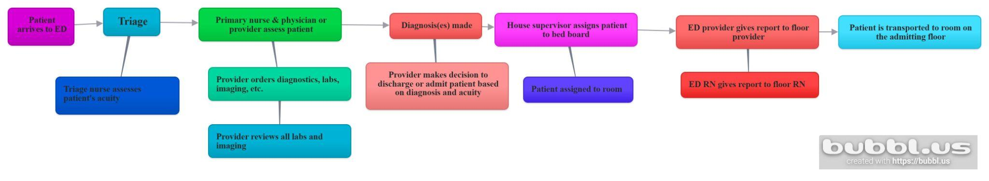

References

Emergency department workflow diagrams. (2018, January). https://www.ahrq.gov/sites/default/files/wysiwyg/professionals/quality-patient-safety/quality-res ources/tools/cap-toolkit/ed-workflowdiagrams.pdf

LLC, Lkc. (n.d.). Create mind maps: Collaborate and present ideas. Bubbl.us - Create Mind Maps. https://bubbl.us/

Mostafa, R., & El-Atawi, K. (2024). Strategies to Measure and Improve Emergency Department
Performance: A Review. Cureus, 16(1), e52879. https://doi.org/10.7759/cureus.52879

